3GPP TS 29.507 V15.1.0 (2018-09)
Technical Specification
3rd Generation Partnership Project;
Technical Specification Group Core Network and Terminals;
5G System; Access and Mobility Policy Control Service;
Stage 3
(Release 15)


The present document has been developed within the 3rd Generation Partnership Project (3GPP TM) and may be further elaborated for the purposes of 3GPP.
The present document has not been subject to any approval process by the 3GPP Organizational Partners and shall not be implemented.
This Specification is provided for future development work within 3GPP only. The Organizational Partners accept no liability for any use of this Specification.
Specifications and Reports for implementation of the 3GPP TM system should be obtained via the 3GPP Organizational Partners' Publications Offices.

Keywords

3GPP
Postal address

3GPP support office address
650 Route des Lucioles - Sophia Antipolis
Valbonne - FRANCE
Tel.: +33 4 92 94 42 00 Fax: +33 4 93 65 47 16
Internet
http://www.3gpp.org
Copyright Notification
No part may be reproduced except as authorized by written permission.
The copyright and the foregoing restriction extend to reproduction in all media.

© 2018, 3GPP Organizational Partners (ARIB, ATIS, CCSA, ETSI, TSDSI, TTA, TTC).
All rights reserved.

UMTS™ is a Trade Mark of ETSI registered for the benefit of its members
3GPP™ is a Trade Mark of ETSI registered for the benefit of its Members and of the 3GPP Organizational Partners
LTE™ is a Trade Mark of ETSI registered for the benefit of its Members and of the 3GPP Organizational Partners
GSM® and the GSM logo are registered and owned by the GSM Association
Contents
Foreword 5
1 Scope 6
2 References 6
3 Definitions and abbreviations 7
3.1 Definitions 7
3.2 Abbreviations 7
4 Access and Mobility Policy Control Service 7
4.1 Service Description 7
4.1.1 Overview 7
4.1.2 Service Architecture 8
4.1.3 Network Functions 9
4.1.3.1 Policy Control Function (PCF) 9
4.1.3.2 NF Service Consumers 9
4.2 Service Operations 10
4.2.1 Introduction 10
4.2.2 Npcf_AMPolicyControl_Create Service Operation 10
4.2.2.1 General 10
4.2.2.2 UE Policy 12
4.2.2.2.0 General 12
4.2.2.2.1 UE Access Network discovery and selection policies 13
4.2.2.2.2 UE Route Selection Policy(URSP) 13
4.2.2.3 AMF Access and Mobility Policy 14
4.2.2.3.1 Service Area Restriction 14
4.2.2.3.2 RFSP Index 14
4.2.3 Npcf_AMPolicyControl_Update Service Operation 14
4.2.3.1 General 14
4.2.3.2 Policy Control Request Triggers 15
4.2.3.3 Encoding of updated policy 16
4.2.4 Npcf_AMPolicyControl_UpdateNotify Service Operation 16
4.2.4.1 General 16
4.2.4.2 Policy update notification 16
4.2.4.3 Request for termination of the policy association 17
4.2.5 Npcf_AMPolicyControl_Delete Service Operation 18
5 Npcf_AMPolicyControl API 19
5.1 Introduction 19
5.2 Usage of HTTP 20
5.2.1 General 20
5.2.2 HTTP standard headers 20
5.2.2.1 General 20
5.2.2.2 Content type 20
5.2.3 HTTP custom headers 20
5.3 Resources 20
5.3.1 Resource Structure 20
5.3.2 Resource: AM Policies 21
5.3.2.1 Description 21
5.3.2.2 Resource definition 21
5.3.2.3 Resource Standard Methods 21
5.3.2.3.1 POST 21
5.3.3 Resource: Individual AM Policy 22
5.3.3.1 Description 22
5.3.3.2 Resource definition 22
5.3.3.3 Resource Standard Methods 22
5.3.3.3.1 GET 22
5.3.3.3.2 DELETE 22
5.3.3.4 Resource Custom Operations 23
5.3.3.4.1 Overview 23
5.3.3.4.2 Operation: Update 23
5.3.3.4.2.1 Description 23
5.3.3.4.2.2 Operation Definition 23
5.4 Custom Operations without associated resources 24
5.5 Notifications 24
5.5.1 General 24
5.5.2 Policy Update Notification 24
5.5.2.1 Description 24
5.5.2.2 Operation Definition 24
5.5.3 Request for termination of the policy association 25
5.5.3.1 Description 25
5.5.3.2 Operation Definition 25
5.6 Data Model 25
5.6.1 General 25
5.6.2 Structured data types 26
5.6.2.1 Introduction 26
5.6.2.2 Type PolicyAssociation 27
5.6.2.3 Type PolicyAssociationRequest 28
5.6.2.4 Type PolicyAssociationUpdateRequest 29
5.6.2.5 Type PolicyUpdate 30
5.6.2.6 Type TerminationNotification 30
5.6.3 Simple data types and enumerations 30
5.6.3.1 Introduction 30
5.6.3.2 Simple data types 30
5.6.3.3 Enumeration: RequestTrigger 31
5.6.3.4 Enumeration: PolicyAssociationReleaseCause 31
5.7 Error handling 31
5.7.1 General 31
5.7.2 Protocol Errors 32
5.7.3 Application Errors 32
5.8 Feature negotiation 32
Annex A (normative): OpenAPI specification 33
A.1 General 33
A.2 Npcf_AMPolicyControl API 33
Annex B (informative): Change history 39

Foreword
This Technical Specification has been produced by the 3rd Generation Partnership Project (3GPP).
The contents of the present document are subject to continuing work within the TSG and may change following formal TSG approval. Should the TSG modify the contents of the present document, it will be re-released by the TSG with an identifying change of release date and an increase in version number as follows:
Version x.y.z
where:
x the first digit:
1 presented to TSG for information;
2 presented to TSG for approval;
3 or greater indicates TSG approved document under change control.
y the second digit is incremented for all changes of substance, i.e. technical enhancements, corrections, updates, etc.
z the third digit is incremented when editorial only changes have been incorporated in the document.

1 Scope
The present specification provides the stage 3 definition of the Access and Mobility Policy Control Service (Npcf_AMPolicyControl) of the 5G System.
The stage 2 definition and procedures of the Access and Mobility Policy Control Service are contained in 3GPP TS 23.502 [3] and 3GPP TS 23.503 [4]. The 5G System Architecture is defined in 3GPP TS 23.501 [2].
Stage 3 call flows are provided in 3GPP TS 29.513 [7].
The Technical Realization of the Service Based Architecture and the Principles and Guidelines for Services Definition of the 5G System are specified in 3GPP TS 29.500 [5] and 3GPP TS 29.501 [6].
The Access and Mobility Policy Control Service is provided by the Policy Control Function (PCF). This service provides Access and Mobility Policies and UE policies.

2 References
The following documents contain provisions which, through reference in this text, constitute provisions of the present document.
- References are either specific (identified by date of publication, edition number, version number, etc.) or non-specific.
- For a specific reference, subsequent revisions do not apply.
- For a non-specific reference, the latest version applies. In the case of a reference to a 3GPP document (including a GSM document), a non-specific reference implicitly refers to the latest version of that document in the same Release as the present document.
[1] 3GPP TR 21.905: "Vocabulary for 3GPP Specifications".
[2] 3GPP TS 23.501: "System Architecture for the 5G System; Stage 2".
[3] 3GPP TS 23.502: "Procedures for the 5G System; Stage 2".
[4] 3GPP TS 23.503: "Policy and Charging Control Framework for the 5G System; Stage 2".
[5] 3GPP TS 29.500: "5G System; Technical Realization of Service Based Architecture; Stage 3".
[6] 3GPP TS 29.501: "5G System; Principles and Guidelines for Services Definition; Stage 3".
[7] 3GPP TS 29.513: "5G System; Policy and Charging Control signalling flows and QoS parameter mapping; Stage 3".
[8] IETF RFC 7540: "Hypertext Transfer Protocol Version 2 (HTTP/2)".
[9] IETF RFC 8259: "The JavaScript Object Notation (JSON) Data Interchange Format".
[10] OpenAPI, "OpenAPI 3.0.0 Specification", https://github.com/OAI/OpenAPI-Specification/blob/master/versions/3.0.0.md
[11] 3GPP TS 29.571: "5G System; Common Data Types for Service Based Interfaces; Stage 3".
[12] 3GPP TS 23.402: "Architecture enhancements for non-3GPP accesses".
[13] 3GPP TS 29.510: "5G System; Network Function Repository Services; Stage 3".
[14] 3GPP TS 29.518: "5G System; Access and Mobility Management Services; Stage 3".
[15] 3GPP TS 24.501: "Non-Access-Stratum (NAS) protocol for 5G System (5GS); Stage 3".
[16] 3GPP TS 24.526: "UE policies for 5G System (5GS); Stage 3".
[17] 3GPP TS 29.519: "5G System; Usage of the Unified Data Repository service for Policy Data, Application Data and Structured Data for Exposure; Stage 3".
[18] 3GPP TS 32.422: "Telecommunication management; Subscriber and equipment trace; Trace control and configuration management".

3 Definitions and abbreviations

3.1 Definitions
For the purposes of the present document, the terms and definitions given in 3GPP TR 21.905 [1] and the following apply. A term defined in the present document takes precedence over the definition of the same term, if any, in 3GPP TR 21.905 [1].

3.2 Abbreviations
For the purposes of the present document, the abbreviations given in 3GPP TR 21.905 [1] and the following apply. An abbreviation defined in the present document takes precedence over the definition of the same abbreviation, if any, in 3GPP TR 21.905 [1].
AMF Access and Mobility Management Function
API Application Programming Interface
DNN Data Network Name
eMBB enhanced Mobile Broadband
GPSI Generic Public Subscription Identifier
GUAMI Globally Unique AMF Identifier
HTTP Hypertext Transfer Protocol
H-PCF Home Policy Control Function
JSON JavaScript Object Notation
MIoT Massive IoT
N3AN Non-3GPP access network
NF Network Function
NSSAI Network Slice Selection Assistance Information
PCF Policy Control Function
PEI Permanent Equipment Identifier
PRA Presence Reporting Area
RFSP RAT Frequency Selection Priority
SSC Session and Service Continuity
SUPI Subscription Permanent Identifier
TA Tracking Area
TAI Tracking Area Identity
UDM Unified Data Management
UDR Unified Data Repository
URLLC Ultra-Reliable Low Latency Communications
UPSC UE policy section code
UPSI UE policy section identifier
URSP UE Route Selection Policy
V-PCF Visited Policy Control Function

4 Access and Mobility Policy Control Service

4.1 Service Description

4.1.1 Overview
The Access and Mobility Policy Control Service, as defined in 3GPP TS 23.502 [3] and 3GPP TS 23.503 [4], is provided by the Policy Control Function (PCF).
This service provides:
- AMF access control and mobility management related policies to the AMF; and
- UE policies such as the UE Route Selection Policy to the UE via the AMF;
and offers the following functionalities:
- policy creation based on a request from the AMF during UE registration;
- notification of the AMF of the updated policies which are subscribed; and
- deletion of the policy context for a UE.

4.1.2 Service Architecture
The 5G System Architecture is defined in 3GPP TS 23.501 [2]. The Policy and Charging related 5G architecture is also described in 3GPP TS 29.513 [7].
The Access and Mobility Policy Control Service (Npcf_AMPolicyControl) is part of the Npcf service-based interface exhibited by the Policy Control Function (PCF).
The known consumers of the Npcf_AMPolicyControl service are the Access and Mobility Management Function (AMF) and the Visited Policy Control Function (V-PCF).
The AMF accesses the Access and Mobility Policy Control Service at the PCF via the N15 Reference point. In the roaming scenario, the N15 reference point is located between the V-PCF in the visited network and the AMF. The V-PCF accesses the Access and Mobility Policy Control Service at the Home Policy Control Function (H-PCF) via the N24 Reference point.
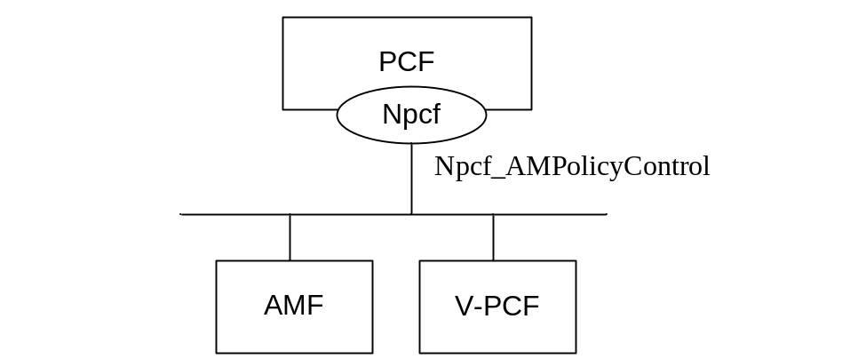
Figure 4.1.2-1: Reference Architecture for the Npcf_AMPolicyControl Service; SBI representation
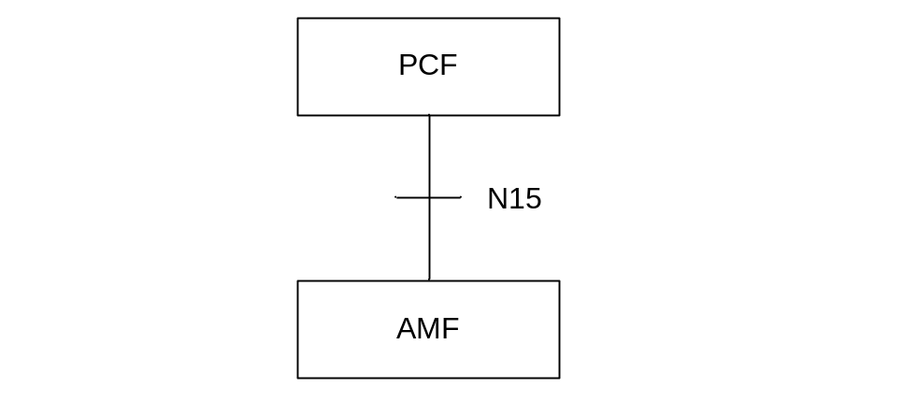
Figure 4.1.2-2: Non-roaming Reference Architecture for the Npcf_AMPolicyControl Service; reference point representation
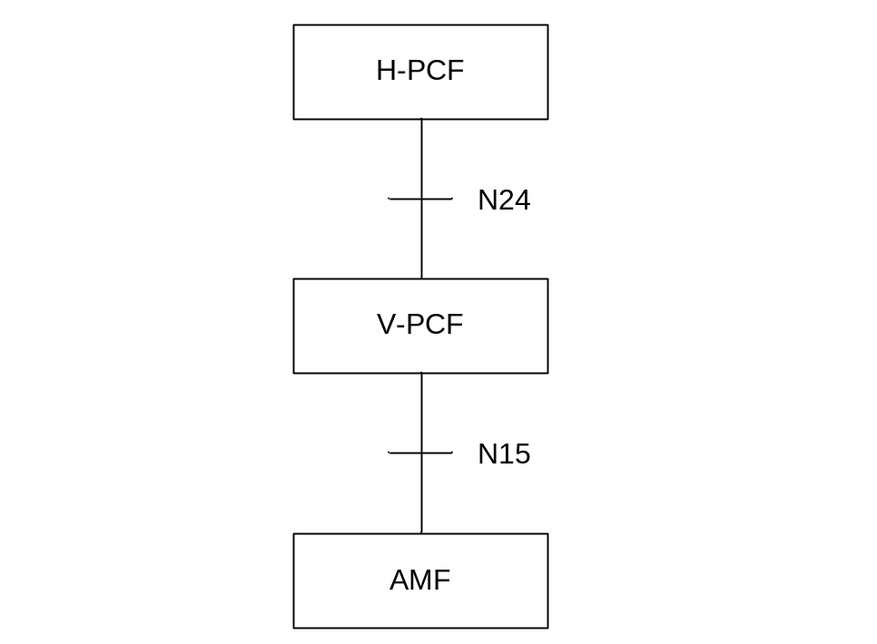
Figure 4.1.3-2: Roaming reference Architecture for the Npcf_AMPolicyControl Service; reference point representation

4.1.3 Network Functions

4.1.3.1 Policy Control Function (PCF)
The Policy Control Function (PCF):
- Supports unified policy framework to govern network behaviour; and
- Provides policy rules to Control Plane function(s) that enforce them, including:
a) Access and Mobility Management related policies for the AMF; and
b) UE policies that include Access Network discovery and selection policies and UE Route Selection Policies.

4.1.3.2 NF Service Consumers
The Access and Mobility Management function (AMF) provides:
- Registration management;
- Connection management;
- Reachability management;
- Mobility Management; and
- Sending of UE Policy towards the served UE.
The Visited Policy Control Function (V-PCF) provides the functions described in subclause 4.1.3.1 towards the visited network.

4.2 Service Operations

4.2.1 Introduction
Table 4.2.1-1: Operations of the Npcf_AMPolicyControl Service
Service operation name | Description | Initiated by
Npcf_AMPolicyControl_Create | Creates an AM Policy Association and provides corresponding policies to the NF consumer. | NF consumer (AMF, V-PCF in roaming case)
Npcf_AMPolicyControl_Update | Updates of an AM Policy Association and provides corresponding policies to the NF consumer when the policy control request trigger is met or the AMF is relocated due to the UE mobility and the old PCF is selected. | NF consumer (AMF, V-PCF in roaming case)
Npcf_AMPolicyControl_UpdateNotify | Provides updated policies to the NF consumer. | PCF (H-PCF and V-PCF in roaming case)
Npcf_AMPolicyControl_Delete | Provides means for the NF consumer to delete the AM Policy Association. | NF consumer (AMF, V-PCF in roaming case)

4.2.2 Npcf_AMPolicyControl_Create Service Operation

4.2.2.1 General
The procedure in the present subclause is applicable when the NF service consumer creates an AM policy association when the UE registers to the network, and when the the AMF is relocated (between the different AMF sets) and the new AMF selects a new PCF. The procedure for the case where the AMF is relocated and the new AMF selects the old PCF is defined in subclause 4.2.3.1.
Figure 4.2.2.1-1 illustrates the creation of a policy association.
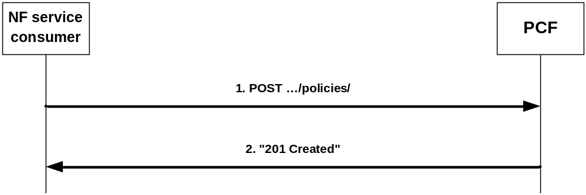
Figure 4.2.2.1-1: Creation of a policy association
When a UE registers and a UE context is being established, the AMF can obtain Service Area Restrictions, RFSP index, and GPSI from the UDM during the update location procedure and shall decide based on local policies whether to request policies from the PCF.
To request policies from the PCF, the NF service consumer (e.g. AMF) shall send an HTTP POST request with: "{apiRoot}/npcf-am-policy-control/v1/policies/" as Resource URI and the PolicyAssociationRequest data structure as request body that shall include:
- Notification URI encoded as "notificationUri" attribute,
and that shall include when available:
- SUPI encoded as "supi" attribute;
NOTE 1: The SUPI is always available except for some emergency sessions where the PEI is available.
- GPSI encoded as "gpsi" attribute;
- Access type encoded as "accessType" attribute;
- Permanent Equipment Identifier (PEI) encoded as "pei" attribute;
- User Location Information encoded as "userLoc" attribute;
- UE Time Zone encoded as "timeZone" attribute;
- Serving PLMN Identifier encoded as "servingPlmn" attribute;
- RAT type encoded as "ratType" attribute;
- Service Area Restriction s (see subclause 4.2.2.3.1) derived from the Service Area Restrictions obtained from the UDM by mapping any service areas denoted by geographical information into Tracking Area Identities (TAIs) and encoded as "servAreaRes" attribute;
- RFSP index (see subclause 4.2.2.3.2) as obtained from the UDM encoded as "rfsp" attribute;
- any received "UPSI LIST TRANSPORT" message of the UE policy delivery protocol defined in Annex D of 3GPP TS 24.501 [15] encoded as "uePolReq" attribute;
- H-PCF ID (if the consumer is V-PCF, when receiving the H-PCF ID from AMF) encoded as "hPcfId" attribute;
- Internal Group Identifier encoded as "groupId" attribute;
- if the NF service consumer is an AMF, the GUAMI encoded as "guami" attribute:
- if the NF service consumer is an AMF, the name of a service produced by the AMF that expects to receive information within Npcf_AMPolicyControl_UpdateNotify service operation encoded as "serviceName" attribute:
- Alternate or backup IPv4 Addess(es) where to send Notifications encoded as "altNotifIpv4Addrs" attribute;
- Alternate or backup IPv6 Addess(es) where to send Notifications encoded as "altNotifIpv6Addrs" attribute; and
- trace control and configuration parameters information encoded as "traceReq" attribute.
Upon the reception of the HTTP POST request, the PCF:
- shall assign a policy association ID;
- if the PCF is a V-PCF, may determine based on operator policy to send as the NF service consumer towards the H-PCF a request for the Creation of a policy association as described in the present clause;
- shall determine the applicable policy (taking into consideration and possibly modifying possibly received Service Area Restrictions and/or RFSP index) and for the V-PCF any policy received from the H-PCF in the reply to the possible request for the Creation of a policy association;
- for the succesfull case shall send a HTTP "201 Created" response with the assigned policy association ID in the "Link" header field
NOTE 2: The assigned policy association ID is thus associated with the SUPI (or PEI in case of emergency PDU Session without SUPI).
and the the PolicyAssociation data type as body including:
- optionally for the H-PCF as service producer communicating with the V-PCF, UE policy (see subclause 4.2.2.2) encoded as "uePolicy" attribute;
- optionally AMF Access and Mobility Policy (see subclause 4.2.2.3), i.e.:
a) Service Area Restrictions encoded as "servAreaRes" attribute; and/or
b) RAT Frequency Selection Priority (RFSP) Index encoded as "rfsp" attribute;
- optionally one or several of the following Policy Control Request Trigger(s) encoded as "triggers" attribute (see subclause 4.2.3.2):
a) Location change (tracking area); and
b) Change of UE presence in PRA;
- if errors occur when processing the HTTP POST request, shall apply error handling procedures as specified in subclause 5.7; and
- if the Policy Control Request Trigger "Change of UE presence in PRA" is provided, the presence reporting areas for which reporting is required encoded as "pras" attribute.
If the PCF received an GUAMI, the PCF may subscribe to GUAMI changes using the AMFStatusChange service operation of the Namf_Communication service specified in 3GPP TS 29.518 [14], and it may use the Nnrf_NFDiscovery Service specified in 3GPP TS 29.510 [13] (using the obtained GUAMI and possibly service name) to query the other AMFs within the AMF set.
If the PCF received a "traceReq" attribute, it shall perform trace procedures as defined in 3GPP TS 32.422 [18].

4.2.2.2 UE Policy

4.2.2.2.0 General
The UE policy consists of UE Access Network discovery and selection policies and UE Route Selection Policy (URSP). The encoding of UE policies is defined in 3GPP TS 24.526 [16].
The UE Policy is transferred to the UE using the UE policy delivery protocol defined in Annex D of 3GPP TS 24.501 [15]. The PCF will receive "MANAGE UE POLICY COMPLETE" messages, "MANAGE UE POLICY COMMAND REJECT" messages and "UPSI LIST TRANSPORT" message and shall send UE policy using the "MANAGE UE POLICY COMMAND" messages. Those messages are transparently forwarded by the AMF.
The "UPSI LIST TRANSPORT" message is transferred transparently during the creation of a policy association, as described in subclause 4.2.2.1.
The V-PCF shall use the Namf_Communication Service defined in 3GPP TS 29.519 [17] to receive "MANAGE UE POLICY COMPLETE" and "MANAGE UE POLICY COMMAND REJECT" messages from the UE and to send MANAGE UE POLICY COMMAND" messages to the UE. The V-PCF shall only send "MANAGE UE POLICY COMMAND" messages below a predefined size limit.
The H-PCF shall use procedures as defined in the present specification to receive "MANAGE UE POLICY COMPLETE" and "MANAGE UE POLICY COMMAND REJECT" messages from the V-PCF and to send MANAGE UE POLICY COMMAND" messages to the V-PCF. The H-PCF shall encode the "MANAGE UE POLICY COMMAND" message in an "uePolicy" attribute.
The PCF may deliver the UE policy to the UE in several "MANAGE UE POLICY COMMAND" messages.
For the purpose of such fragmented delivery and subsequent partial updates of UE policies, the UE policy is divided into policy sections. Such policy sections may be predefined in the PCF, may be retrieved by the PCF from the UDR as specified in 3GPP TS 29.519 [17], or may be dynamically generated by the PCF, but shall comply to the rules below. The PCF may combine several policy sections into one "MANAGE UE POLICY COMMAND" message if the predefined size limit is observed.
The following rules apply for policy sections:
- The size shall be below the predefined size limit.
- The policy section shall only contain complete URSP rule(s), WLANSP rule(s), and/or complete N3AN node configuration information, but no fractions of such rules or configuration information.
- To ease a subsequent partial update of UE policies, policy sections should only contain a small number of URSP rule(s), and/or WLANSP rule(s),
- The entire content of a policy section shall be provided by a single PLMN.
A PCF shall only determine policy sections of its own PLMN. However, a V-PCF may forward UE policy sections received from the H-PCF to the UE.
Each UE policy section is identified by a UE policy section identifier (UPSI). The UPSI is composed of two parts:
a) a PLMN ID part containing the PLMN ID for the PLMN of the PCF which provides the UE policies; and
b) a UE policy section code (UPSC) containing a unique value within the PLMN selected by the PCF.
The PCF provides an UPSI when providing a new UE policy section and can then identify that policy section using that UPSI when requesting that this UE policy section is modified or deleted, as specified in Annex D of 3GPP TS 24.501 [15].
The PCF may store UPSCs and related policy sections of the own PLMN it provided to a UE in the UDR as specified in 3GPP TS 29.519 [17].
Editor's note: It is ffs if a V-PCF stores such information separately for each visiting UE and maintains this information after the termination of the UE policy association,
When receiving the "UPSI LIST TRANSPORT" message, the PCF shall determine based on the UPSIs indicated in that message, UPCS stored in the UDR and local policy whether any new UE policy sections need to be installed and any existing UE policy section need to be updated or deleted. A V-PCF may also send an "UPSI LIST TRANSPORT" message with the UPSIs of the HPLMN received in the original "UPSI LIST TRANSPORT" message to the H-PCF and will then receive possible new or modified policy sections determined by the HPLMN in a "MANAGE UE POLICY COMMAND". If the PCF determines that changes are required and/or receives possible new or modified policy sections determined by the HPLMN, it shall send the determined new, updated or deleted policy sections using one or several "MANAGE UE POLICY COMMAND" messages towards the NF service consumer.
After sending a "MANAGE UE POLICY COMMAND" messages, the PCF shall wait for a related confirmation in a "MANAGE UE POLICY COMPLETE" messages or failure indication in a "MANAGE UE POLICY COMMAND REJECT" message. When receiving no such message until the expiry of a supervision timer specified in Annex D of 3GPP TS 24.501 [15], or when receiving a failure indication, the PCF should re-send related instructions for the policy sections.

4.2.2.2.1 UE Access Network discovery and selection policies
UE Access Network discovery and selection policies are used by the UE to select non-3GPP accesses and to decide how to route traffic between the selected 3GPP and non 3GPP accesses.
In this release of the specification, the Access Network Discovery & Selection policy shall contain only rules that aid the UE in selecting a WLAN access network. Rules for selecting other types of non-3GPP access networks are not specified.
The WLAN access network selected by the UE with the use of Access Network Discovery & Selection policy may be used for direct traffic offload (i.e. sending traffic to the WLAN outside of a PDU Session) and for registering to 5GC via a N3IWF.
The Access Network Discovery & Selection policy contains one or more WLAN Selection Policy (WLANSP) rules and Non-3GPP access network (N3AN) node configuration information.
N3AN node configuration information is used to control UE behaviour related to selection of either N3IWF or ePDG for accessing 5GCN via non-3GPP access.
UE Access Network discovery and selection policies are encoded as defined in 3GPP TS 24.526 [16].
UE Access Network discovery and selection policies may be provided by a V-PCF or a H-PCF..

4.2.2.2.2 UE Route Selection Policy(URSP)
The UE Route Selection Policy is used by the UE to determine how to route outgoing traffic.
The UE Route Selection Policy shall consist of one or several URSP rules.
URSP rules are encoded as defined in 3GPP TS 24.526 [16].
UE Route Selection Policy may only be provided by a H-PCF, but shall not be provided by a V-PCF.

4.2.2.3 AMF Access and Mobility Policy

4.2.2.3.1 Service Area Restriction
If service area restrictions are enabled, the Service Area Restriction information is encoded using the "ServiceArea Restriction" data type defined in 3GPP TS 29.571 [11] and consists of:
- the maximum number of allowed TAs that can be traversed encoded as "maxNumOfTAs" attribute; and/or
- either:
a) a list of allowed Tracking Area Identities (TAIs) encoded as "tacs" attributes within the "areas" attribute; and
b) the "restrictionType" attribute set to "ALLOWED_AREAS";
- or:
a) a list of not allowed Tracking Area Identities (TAIs) encoded as "tacs" attributes within the "areas" attribute; and
b) the "restrictionType" attribute set to "NOT_ALLOWED_AREAS".

4.2.2.3.2 RFSP Index
The RFSP Index is an index referring to a UE information used locally by the Access Network in order to apply specific radio resource management strategies. It shall be encoded using the RfspIndex data type defined in 3GPP TS 29.571 [11].

4.2.3 Npcf_AMPolicyControl_Update Service Operation

4.2.3.1 General
The procedure in the present subclause is applicable when the NF service consumer modifies an existing AM policy association (including the case where the AMF is relocated and the new AMF selects to maintain the policy association with the old PCF and to update the Notification URI).
Figure 4.2.3.1-1 illustrates the update of a policy association.
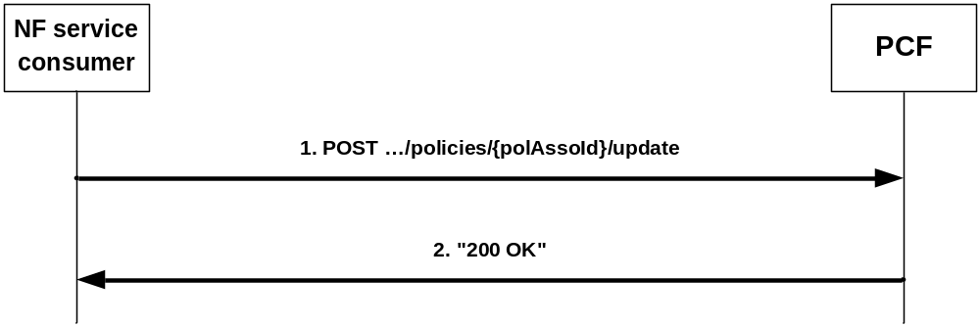
Figure 4.2.3.1-1: Update of a policy association
The AMF as NF service consumer invokes this procedure when a policy control request trigger (see subclause 4.2.3.2) occurs. When the Service Area restriction change trigger or the RFSP index change trigger occur, the AMF shall always invoke the procedure. When the location change trigger or the change of UE presence in PRA trigger occurs, the AMF shall only invoke the procedure if the PCF has subscribed to that event trigger.
If an AMF knows by implementation specific means that the UE context has been transferred to an AMF with another GUAMI within the AMF set, it may also invoke this procedure to update the Notification URI.
NOTE: Either the old or the new AMF can invoke this procedure.
During the AMF relocation, if the new AMF received the resource URI of the individual AM Policy from the old AMF and selects the old PCF, the new AMF shall also invoke this procedure to update the Notification URI.
To request policies from the PCF or to update the Notification URI, or to update the trace control configuration, or to request the termination of trace, the NF Service Consumer (e.g. AMF) shall request the update of an AM Policy Association by providing relevant parameters about the UE context by sending an HTTP POST request with "{apiRoot}/npcf-am-policy-control/v1/policies/{polAssoId}/update" as Resource URI and the PolicyAssociationUpdateRequest data structure as request body that shall include:
- at least one of the following:
1. a new Notification URI encoded in the "notificationUri" attribute; and/or
2. observed Policy Control Request Trigger(s) (see subclause 4.2.3.2) encoded as "triggers" attribute;
3. if a Service Area restriction change occurred, the Service Area Restrictions (see subclause 4.2.2.3.1) as obtained from the UDM encoded as "servAreaRes" attribute;
4. if a RFSP index change occurred, the RFSP index (see subclause 4.2.2.3.2) as obtained from the UDM encoded as "rfsp" attribute;
5. if a UE location change occurred, the UE location encoded as "userLoc" attribute;
6. if a "MANAGE UE POLICY COMPLETE" message or a "MANAGE UE POLICY COMMAND REJECT" message of the UE policy delivery protocol defined in Annex D of 3GPP TS 24.501 [15] has been received by the NF service consumer, the message encoded as "uePolDelResult" attribute;
7. if the Policy Control Request Trigger "Change of UE presence in PRA" is provided, the presence reporting areas for which reporting was requested and the status has changed encoded as "praStatuses" attribute.
8. if the trace control configuration needs to be updated, trace control and configuration parameters information encoded as "traceReq" attribute;and
9. if trace needs to be terminated, the "traceReq" attribute set to the Null value;
NOTE: An alternate NF service consumer than the one that requested the generation of the subscription resource can send the request. For instance, an AMF as service consumer can change.
Upon the reception of the HTTP POST request, the PCF:
- if the PCF is a V-PCF and has an established policy association, shall determine based on operator policy and requested event triggers of the H-PCF whether to send as the NF service consumer towards the H-PCF a request for the update of the policy association as described in the present clause;
- shall determine the applicable policy based on local policy and for the V-PCF any policy received from the H-PCF in the reply to the possible request for the update of a policy association;
- for the succesfull case shall send a HTTP "200 OK" response with the PolicyUpdate data type as body with possible updates for that applicable policy and Policy Control Request Trigger(s) encoded as described in subclause 4.2.3.3;
- if errors occur when processing the HTTP POST request, shall apply error handling procedures as specified in subclause 5.7; and
If the PCF received a "traceReq" attribute, it shall perform trace procedures as defined in 3GPP TS 32.422 [18].

4.2.3.2 Policy Control Request Triggers
The following Policy Control Request Triggers are defined (see subclause 6.1.2.5 of 3GPP TS 23.503 [4]):
- "LOC_CH", i.e. location change (tracking area): the tracking area of the UE has changed;
- "PRA_CH", i.e. change of UE presence in PRA: the UE is entering/leaving a Presence Reporting Area;
- "SERV_AREA _CH", i.e. Service Area Restriction change: the UDM notifies the AMF that the subscribed service area restriction information has changed; and
- "RFSP_CH", i.e. RFSP index change: the UDM notifies the AMF that the subscribed RFSP index has changed; and
- "UE_POLICY", i.e. a "MANAGE UE POLICY COMPLETE" message or a "MANAGE UE POLICY COMMAND REJECT" message, as defined in Annex D.5 of 3GPP TS 24.501 [15], has been received by the AMF and is being forwarded.

4.2.3.3 Encoding of updated policy
Updated policies shall be encoded within the PolicyUpdate data type that may include:
- UE policy (see subclause 4.2.2.2) encoded as "uePolicy" attribute;
- AMF Access and Mobility Policy (see subclause 4.2.2.3) Service Area Restriction encoded as "servAreaRes" attribute;
- AMF Access and Mobility Policy (see subclause 4.2.2.3) RFSP Index encoded as "rfsp" attribute;
- updated Policy Control Request Trigger(s) (see subclause 4.2.3.2) encoded as "triggers" attribute i.e.:
1) either one or several of the following:
a) Location change (tracking area); or
b) Change of UE presence in PRA; or
2) a "NULL" value to request the removal of all previously installed Policy Control Request Trigger(s); and
- if the Policy Control Request Trigger "Change of UE presence in PRA" is provided or if that trigger was already set but the requested presence reporting areas need to be changed, the presence reporting areas for which reporting is required encoded as "pras" attribute encoded as follows:
a) A new entry shall be added by supplying a new identifier as key and the corresponding PresenceInfo data type instance with complete contents as value as an entry within the map.
b) An existing entry shall be modified by supplying the existing identifier as key and the PresenceInfo data type instance with complete contents as value as an entry within the map.
c) An existing entry shall be deleted by supplying the existing identifier as key and "NULL" as value as an entry within the map.
d) For an unmodified entry, no entry needs to be provided within the map.

4.2.4 Npcf_AMPolicyControl_UpdateNotify Service Operation

4.2.4.1 General
The PCF may decide to update policies or to request the termination of the policy association and shall then use an Npcf_AMPolicyControl_UpdateNotify service operation.
The following procedures using the Npcf_AMPolicyControl_UpdateNotify service operation are supported:
- policy update notification; and
- request for termination of the policy association.

4.2.4.2 Policy update notification
Figure 4.2.4.2-1 illustrates the policy update notification.
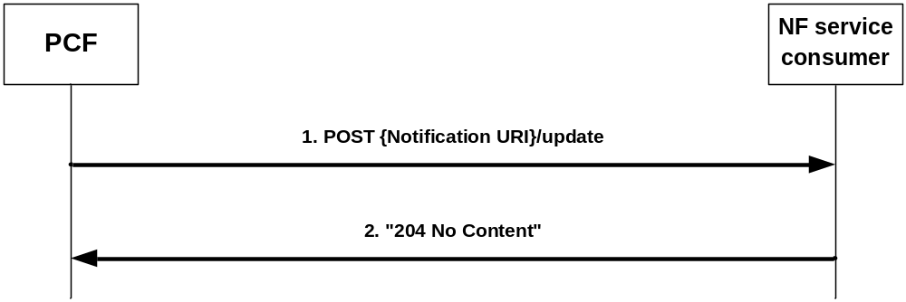
Figure 4.2.4.2-1: policy update notification
The PCF may decide to update policies and shall then send an HTTP POST request with "{Notification URI}/update" as URI (where the Notification URI was previously supplied by the NF service consumer) and the PolicyUpdate data structure as request body encoded as described in subclause 4.2.3.3.
Upon the reception of the HTTP POST request, the NF service consumer:
- shall enforce the received updated policy;
- if the V-PCF is the NF service consumer, shall send as NF service producer for the corresponding policy association (towards the AMF) a corresponding policy update notification request according to the present clause;
- shall either send a HTTP "204 No Content" response indicating the success of the enforcement or an appropriate failure response, for the V-PCF as the NF service consumer taking into consideration a reply received for the possible corresponding policy update notification request according to the previous bullet; and
- if errors occur when processing the HTTP POST request, shall apply error handling procedures as specified in subclause 5.7.
If the AMF as NF service consumer is not able to handle the notification but knows by implementation specific means that another AMF is able to handle the notification, it shall reply with an HTTP "307 temporary redirect" error response pointing to the URI of the new AMF. If the AMF is not able to handle the notification but another unknown AMF could possibly handle the notification, it shall reply with an HTTP "404 Not found" error response.
If the PCF receives a "307 temporary redirect" response, the PCF shall use this URL as Notification URL in subsequent communication and shall resend the failed policy update notification request to that URL.
If the PCF becomes aware that a new AMF is requiring notifications (e.g. via the "404 Not found" response or via Namf_Communication service AMFStatusChange Notifications, see 3GPP TS 29.518 [14], or via link level failures), and the PCF knows alternate or backup IPv4 or IPv6 Addess(es) where to send Notifications (e.g. via "altNotifIpv4Addrs" or "altNotifIpv6Addrs" attributes received when the policy association was created or via AMFStatusChange Notifications, or via the Nnrf_NFDiscovery Service specified in 3GPP TS 29.510 [13] (using the service name and GUAMI obtained during the creation of the subscription) to query the other AMFs within the AMF set), the PCF shall exchange the authority part of the corresponding Notification URL with one of those addresses and shall use that URL in subsequent communication. If the PCF received a "404 Not found" response, the PCF should resend the failed policy update notification request to that URL.

4.2.4.3 Request for termination of the policy association
Figure 4.2.4.3-1 illustrates the request for a termination of the policy association.
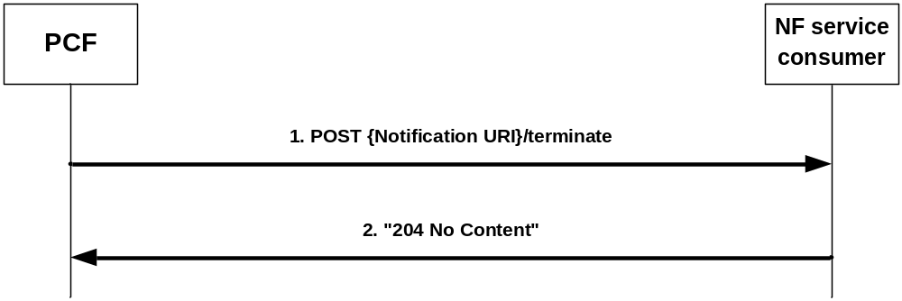
Figure 4.2.4.3-1: request for a termination of the policy association
The PCF may to request the termination of the policy association and shall then send an HTTP POST request with "{Notification URI}/terminate" as URI (where the Notification URI was previously supplied by the NF service consumer) and the TerminationNotification data structure as request body that shall include:
- the policy association ID encoded as "polAssoId" attribute; and
- the cause why the PCF requests the termination of the policy association encoded as "cause" attribute.
Upon the reception of the HTTP POST request, the NF service consumer:
- if the V-PCF is the NF service consumer, shall send as NF service producer for the corresponding policy association (towards the AMF) a request for a termination of the policy association according to the present clause;
- shall either send a HTTP "204 No Content" responsefor the succesfull processing of the HTTP POST request or an appropriate failure response, for the V-PCF as the NF service consumer taking into consideration a reply received for the possible corresponding policy update notification request according to the previous bullet; and
- if errors occur when processing the HTTP POST request, shall apply error handling procedures as specified in subclause 5.7.
After the succesfull processing of the HTTP POST request, any NF service consumer except for the V-PCF shall invoke the Npcf_AMPolicyControl_Delete Service Operation defined in subclause 4.2.5 to terminate the policy association.
If the AMF AMF as NF service consumer is not able to handle the notification but knows by implementation specific means that another AMF is able to handle the notification, it shall reply with an HTTP "307 temporary redirect" error response pointing to the URI of the new AMF. If the AMF is not able to handle the notification but another unknown AMF could possibly handle the notification, it shall reply with an HTTP "404 Not found" error response.
If the PCF receives a "307 temporary redirect" response, the PCF shall use this URL as Notification URL in subsequent communication and shall resend the failed request for termination of the policy association to that URL.
If the PCF becomes aware that a new AMF is requiring notifications (e.g. via the "404 Not found" response or via Namf_Communication service AMFStatusChange Notifications, see 3GPP TS TS 29.518 [14], or via link level failures), and the PCF knows alternate or backup IPv4 or IPv6 Addess(es) where to send Notifications (e.g. via "altNotifIpv4Addrs" or "altNotifIpv6Addrs" attributes received when the policy association was created or via AMFStatusChange Notifications, or via the Nnrf_NFDiscovery Service specified in 3GPP TS 29.510 [13] (using the service name and GUAMI obtained during the creation of the subscription) to query the other AMFs within the AMF set), the PCF shall exchange the authority part of the corresponding Notification URL with one of those addresses and shall use that URL in subsequent communication. If the PCF received a "404 Not found" response, the PCF should resend the failed request for termination of the policy association to that URL.

4.2.5 Npcf_AMPolicyControl_Delete Service Operation
Figure 4.2.5-1 illustrates the deletion of a policy association.
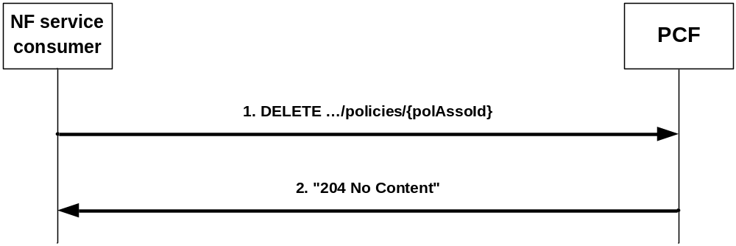
Figure 4.2.5-1: deletion of a policy association
The AMF as NF service consumer requests that the policy association is deleted when the corresponding UE context is terminated, e.g. during UE de-registration or handover.
To request that the policy association is deleted, the NF service consumer (e.g. AMF) shall send an HTTP DELETE request with "{apiRoot}/npcf-am-policy-control/v1/policies/{polAssoId}" as Resource URI.
Upon the reception of the HTTP DELETE request, the PCF:
- shall delete the policy association;
- if the PCF is a V-PCF and has an established corresponding policy association towards the H-PCF, send as the NF service consumer towards the H-PCF a request for the deletion of that policy association as described in the present clause;
- send either a an HTTP "204 No Content" response indicating the success of the deletion or an appropriate failure response, for the V-PCF as PCF taking into consideration a reply received for the possible policy association deletion request according to the previous bullet; and
- if errors occur when processing the HTTP DELETE request, apply error handling procedures as specified in subclause 5.7.

5 Npcf_AMPolicyControl API

5.1 Introduction
The Access and Mobility Policy Control Service shall use the Npcf_AMPolicyControl API.
The request URI used in HTTP request from the NF service consumer towards the PCF shall have the structure defined in subclause 4.4.1 of 3GPP TS 29.501 [2], i.e.:
{apiRoot}/{apiName}/{apiVersion}/{apiSpecificResourceUriPart}
with the following components:
- The {apiRoot} shall be set as described in 3GPP TS 29.501 [2].
- The {apiName} shall be "npcf-am-policy-control".
- The {apiVersion} shall be "v1".
- The {apiSpecificResourceUriPart} shall be set as described in subclause 5.3.

5.2 Usage of HTTP

5.2.1 General
HTTP/2, IETF RFC 7540 [8], shall be used as specified in clause 5 of 3GPP TS 29.500 [4].
HTTP/2 shall be transported as specified in subclause 5.3 of 3GPP TS 29.500 [5].
The OpenAPI [10] specification of HTTP messages and content bodies for the Npcf_AMPolicyControl is contained in Annex A.

5.2.2 HTTP standard headers

5.2.2.1 General
See subclause 5.2.2 of 3GPP TS 29.500 [4] for the usage of HTTP standard headers.

5.2.2.2 Content type
JSON, IETF RFC 8259 [9], shall be used as content type of the HTTP bodies specified in the present specification as specified in subclause 5.4 of 3GPP TS 29.500 [4].

5.2.3 HTTP custom headers
The mandatory HTTP custom header fields specified in subclause 5.2.3.2 of 3GPP TS 29.500 [4] shall be applicable

5.3 Resources

5.3.1 Resource Structure
x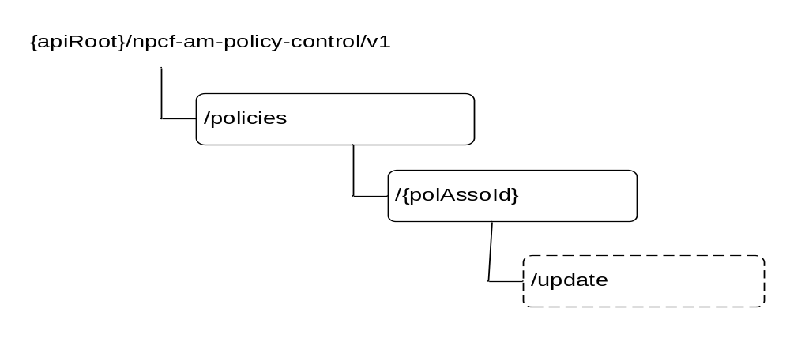
Figure 5.3.1-1: Resource URI structure of the Npcf_AMPolicyControl API
Table 5.3.1-1 provides an overview of the resources and applicable HTTP methods.
Table 5.3.1-1: Resources and methods overview
Resource name | Resource URI | HTTP method or custom operation | Description
AM Policies | {apiRoot}/  npcf-am-policy-control/  v1/policies/ | POST | Create a new Individual AM Policy resource.
Individual AM Policy | {apiRoot}  /npcf-am-policy-control/  v1/policies/  {polAssoId} | GET | Read the Individual AM Policy resource.
Individual AM Policy |  | DELETE | Delete the Individual AM Policy resource.
Individual AM Policy | {apiRoot}  /npcf-am-policy-control/  v1/policies/  {polAssoId}/update | update (POST) | Report observed event trigger and obtain updated policies.

5.3.2 Resource: AM Policies

5.3.2.1 Description
This resource represents a collection of AM policy associations.

5.3.2.2 Resource definition
Resource URI: {apiRoot}/npcf-am-policy-control/v1/policies/
This resource shall support the resource URI variables defined in table 5.3.2.2-1.
Table 5.3.2.2-1: Resource URI variables for this resource
Name | Definition
apiRoot | See subclause 5.1

5.3.2.3 Resource Standard Methods

5.3.2.3.1 POST
This method shall support the URI query parameters specified in table 5.3.2.3.1-1.
Table 5.3.2.3.1-1: URI query parameters supported by the POST method on this resource
Name | Data type | P | Cardinality | Description
n/a

This method shall support the request data structures specified in table 5.3.2.3.1-2 and the response data structures and response codes specified in table 5.3.2.3.1-3.
Table 5.3.2.3.1-2: Data structures supported by the POST Request Body on this resource
Data type | P | Cardinality | Description
PolicyAssociationRequest | M | 1 | Input parameters for the creation of a policy association.

Table 5.3.2.3.1-3: Data structures supported by the POST Response Body on this resource
Data type | P | Cardinality | Response codes | Description
PolicyAssociation | M | 1 | 201 Created | Policy association was created and policies are being provided.
NOTE: The mandatory HTTP error status codes for the POST method listed in Table 5.2.7.1-1 of 3GPP TS 29.500 [5] also apply.

5.3.3 Resource: Individual AM Policy

5.3.3.1 Description
This resource represents an individual AM policy association.

5.3.3.2 Resource definition
Resource URI: {apiRoot}/npcf-am-policy-control/v1/policies/{polAssoId}
This resource shall support the resource URI variables defined in table 5.3.2.2-1.
Table 5.3.2.2-1: Resource URI variables for this resource
Name | Definition
apiRoot | See subclause 5.1.
polAssoId | Identifier of a policy association.

5.3.3.3 Resource Standard Methods

5.3.3.3.1 GET
This method shall support the URI query parameters specified in table 5.3.2.3.1-1.
Table 5.3.3.3.1-1: URI query parameters supported by the GET method on this resource
Name | Data type | P | Cardinality | Description
n/a

This method shall support the request data structures specified in table 5.3.2.3.1-2 and the response data structures and response codes specified in table 5.3.2.3.1-3.
Table 5.3.3.3.1-2: Data structures supported by the GET Request Body on this resource
Data type | P | Cardinality | Description
n/a

Table 5.3.3.3.1-3: Data structures supported by the GET Response Body on this resource
Data type | P | Cardinality | Response codes | Description
PolicyAssociation | M | 1 | 200 OK
NOTE: The mandatory HTTP error status codes for the GET method listed in Table 5.2.7.1-1 of 3GPP TS 29.500 [5] also apply.

5.3.3.3.2 DELETE
This method shall support the URI query parameters specified in table 5.3.3.3.2-1.
Table 5.3.3.3.2-1: URI query parameters supported by the DELETE method on this resource
Name | Data type | P | Cardinality | Description
n/a

This method shall support the request data structures specified in table 5.3.3.3.2-2 and the response data structures and response codes specified in table 5.3.3.3.2-3.
Table 5.3.3.3.2-2: Data structures supported by the DELETE Request Body on this resource
Data type | P | Cardinality | Description
n/a

Table 5.3.3.3.2-3: Data structures supported by the DELETE Response Body on this resource
Data type | P | Cardinality | Response codes | Description
n/a |  |  | 204 No Content | The policy association was successfully deleted.
NOTE: The mandatory HTTP error status codes for the DELETE method listed in Table 5.2.7.1-1 of 3GPP TS 29.500 [5] also apply.

5.3.3.4 Resource Custom Operations

5.3.3.4.1 Overview
Table 5.3.3.4.1-1: Custom operations
Custom operation URI | Mapped HTTP method | Description
{apiRoot}  /npcf-am-policy-control/v1/  policies/  {polAssoId}/update | POST | Report observed event trigger and obtain updated policies.

5.3.3.4.2 Operation: Update

5.3.3.4.2.1 Description
The update custom operation allows an NF service consumer to report the occurrence on a police request trigger and to obtain related updated policies.

5.3.3.4.2.2 Operation Definition
This operation shall support the request data structures specified in table 5.3.3.4.2.2-1 and the response data structure and response codes specified in table 5.3.3.4.2.2-2.
Table 5.3.3.4.2.2-1: Data structures supported by the POST Request Body on this resource
Data type | P | Cardinality | Description
PolicyAssociationUpdateRequest | M | 1 | Describes the observed event trigger(s).

Table 5.3.3.4.2.2-2: Data structures supported by the POST Response Body on this resource
Data type | P | Cardinality | Response codes | Description
PolicyUpdate | M | 1 | 200 OK | Describes updated policies.
NOTE: The mandatory HTTP error status codes for the POST method listed in Table 5.2.7.1-1 of 3GPP TS 29.500 [5] also apply.

5.4 Custom Operations without associated resources
None.

5.5 Notifications

5.5.1 General
Table 5.5.1-1: Notifications
Custom operation URI | Mapped HTTP method | Description
{Notification URI}/update | POST | Policy Update Notification.
{Notification URI}/terminate | POST | Request for termination of the policy association.

5.5.2 Policy Update Notification

5.5.2.1 Description
This notification is used by the PCF to provide updates of access and mobility policies to the NF service consumer.

5.5.2.2 Operation Definition
This operation shall support the request data structures specified in table 5.5.2.2-1 and the response data structure and response codes specified in table 5.5.2.2-2.
Table 5.5.2.2-1: Data structures supported by the POST Request Body on this resource
Data type | P | Cardinality | Description
PolicyUpdate | M | 1 | Updated policies.

Table 5.5.2.2-2: Data structures supported by the POST Response Body on this resource
Data type | P | Cardinality | Response codes | Description
n/a |  |  | 204 No Content | The policies were successfully updated.
n/a |  |  | 307 temporary redirect | The NF service consumer shall generate a Location header field containing a URI pointing to another NF service consumer to which the notification should be send.
ProblemDetails | M | 1 | 404 Not Found | The NF service consumer can use this response when the notification can be sent to another unknown host.

5.5.3 Request for termination of the policy association

5.5.3.1 Description
This notification is used by the PCF to request the termination of a policy association.

5.5.3.2 Operation Definition
This operation shall support the request data structures specified in table 5.5.3.2-1 and the response data structure and response codes specified in table 5.5.3.2-2.
Table 5.5.3.2-1: Data structures supported by the POST Request Body on this resource
Data type | P | Cardinality | Description
TerminationNotification | M | 1 | Request to terminate the policy association.

Table 5.5.3.2-2: Data structures supported by the POST Response Body on this resource
Data type | P | Cardinality | Response codes | Description
n/a |  |  | 204 No Content | The request for policy association termination was received.
n/a |  |  | 307 temporary redirect | The NF service consumer shall generate a Location header field containing a different URI pointing to another NF service consumer to which the notification should be send.
ProblemDetails | M | 1 | 404 Not Found | The NF service consumer can use this response when the notification can be sent to another unknown host.

5.6 Data Model

5.6.1 General
This subclause specifies the application data model supported by the API.
Table 5.6.1-1 specifies the data types defined for the Npcf_AMPolicyControl service based interface protocol.
Table 5.6.1-1: Npcf_AMPolicyControl specific Data Types
Data type | Section defined | Description | Applicability
PolicyAssociation | 5.6.2.2 | Description of a policy association that is returned by the PCF when a policy Association is created, updated, or read.
PolicyAssociationReleaseCause | 5.6.3.4 | The cause why the PCF requests the termination of the policy association.
PolicyAssociationRequest | 5.6.2.3 | Information that NF service consumer provides when requesting the creation of a policy association.
PolicyAssociationUpdateRequest | 5.6.2.4 | Information that NF service consumer provides when requesting the update of a policy association.
PolicyUpdate | 5.6.2.5 | Updated policies that the PCF provides in a notification or in the reply to an Update Request.
RequestTrigger | 5.6.3.3 | Enumeration of possible Request Triggers.
TerminationNotification | 5.6.2.6 | Request to terminate a policy Association that the PCF provides in a notification.
UePolicy | 5.6.3.2 | UE Policies
UePolicyDeliveryResult | 5.6.3.2 | UE Policy delivery Result
UePolicyRequest | 5.6.3.2 | Request for UE Policies

Table 5.6.1-2 specifies data types re-used by the Npcf_AMPolicyControl service based interface protocol from other specifications, including a reference to their respective specifications and when needed, a short description of their use within the Npcf_AMPolicyControl service based interface.
Table 5.6.1-2: Npcf_AMPolicyControl re-used Data Types
Data type | Reference | Comments | Applicability
AccessType | 3GPP TS 29.571 [11]
Gpsi | 3GPP TS 29.571 [11] | Generic Public Subscription Identifier
GroupId | 3GPP TS 29.571 [11]
Guami | 3GPP TS 29.571 [11] | Globally Unique AMF Identifier
Ipv4Addr | 3GPP TS 29.571 [11]
Ipv6Addr | 3GPP TS 29.571 [11]
NetworkId | 3GPP TS 29.571 [11]
Pei | 3GPP TS 29.571 [11] | Permanent Equipment Identifier
PresenceInfo | 3GPP TS 29.571 [11] | Presence reporting area information
ProblemDetails | 3GPP TS 29.571 [11]
Uri | 3GPP TS 29.571 [11]
UserLocation | 3GPP TS 29.571 [11]
RatType | 3GPP TS 29.571 [11]
RfspIndex | 3GPP TS 29.571 [11]
ServiceAreaRestriction | 3GPP TS 29.571 [11] | Within the areas attribute, only tracking area codes shall be included.
Supi | 3GPP TS 29.571 [11] | Subscription Permanent Identifier
SupportedFeatures | 3GPP TS 29.571 [11] | Used to negotiate the applicability of the optional features defined in table 5.8-1.
TimeZone | 3GPP TS 29.571 [11]
TraceData | 3GPP TS 29.571 [11]

5.6.2 Structured data types

5.6.2.1 Introduction
This subclause defines the structures to be used in resource representations.

5.6.2.2 Type PolicyAssociation
Table 5.6.2.2-1: Definition of type PolicyAssociation
Attribute name | Data type | P | Cardinality | Description | Applicability
request | PolicyAssociationRequest | O | 0..1 | The information provided by the NF service consumer when requesting the creation of a policy association
uePolicy | FFF | O | 0..1 | The UE policy as determined by the PCF.
triggers | array(RequestTrigger) | O | 1..N | Request Triggers that the PCF subscribes. Only values "LOC_CH" and "PRA_CH" are permitted.
servAreaRes | FFS | O | 0..1 | Service Area Restriction as part of the AMF Access and Mobility Policy as determined by the PCF
rfsp | RfspIndex | O | 0..1 | RFSP Index as part of the AMF Access and Mobility Policy as determined by the PCF.
pras | map(PresenceInfo) | C | 1..N | If the Trigger "PRA_CH" is provided, the presence reporting area(s) for which reporting is requested shall be provided. The praId attribute within the PresenceInfo data type shall also be the key of the map. The praStatus attribute within the PresenceInfo data type shall not be supplied.
suppFeat | SupportedFeatures | M | 1 | Indicates the negotiated supported features.

5.6.2.3 Type PolicyAssociationRequest
Table 5.6.2.3-1: Definition of type PolicyAssociationRequest
Attribute name | Data type | P | Cardinality | Description | Applicability
notificationUri | Uri | M | 1 | Identifies the recipient of Notifications sent by the PCF.
altNotifIpv4Addrs | array(Ipv4Addr) | O | 1..N | Alternate or backup IPv4 Addess(es) where to send Notifications.
altNotifIpv6Addrs | array(Ipv6Addr) | O | 1..N | Alternate or backup IPv6 Addess(es) where to send Notifications.
supi | Supi | C | 0..1 | Subscription Permanent Identifier. Shall be provided when available.
gpsi | Gpsi | C | 0..1 | Generic Public Subscription Identifier. Shall be provided when available.
accessType | AccessType | C | 0..1 | The Access Type where the served UE is camping. Shall be provided when available.
pei | Pei | C | 0..1 | The Permanent Equipment Identifier of the served UE. Shall be provided when available.
userLoc | UserLocation | C | 0..1 | The location of the served UE. Shall be provided when available.
timeZone | TimeZone | C | 0..1 | The time zone where the served UE is camping. Shall be provided when available.
servingPlmn | NetworkId | C | 0..1 | The serving PLMN where the served UE is camping. Shall be provided when available.
ratType | RatType | C | 0..1 | The RAT Type where the served UE is camping. Shall be provided when available.
groupId | GroupId | C | 0..1 | Internal Group Identifier of the served UE. Shall be provided when available.
hPcfId | string | C | 0..1 | H-PCF Identifier. Shall be provided when available.
servAreaRes | ServiceAreaRestriction | C | 0..1 | Service Area Restriction as part of the AMF Access and Mobility Policy. Shall be provided when available.
rfsp | RfspIndex | C | 0..1 | RFSP Index as part of the AMF Access and Mobility Policy. Shall be provided when available.
uePolReq | UePolicyRequest | C | 0..1 | A request for UE Policies. Shall be provided when the AMF receives an "UPSI LIST TRANSPORT" message, as defined in Annex D.5.4 of 3GPP TS 24.501 [15] .
guami | Guami | C | 0..1 | The Globally Unique AMF Identifier (GUAMI) shall be provided by an AMF as service consumer.
serviceName | string | O | 0..1 | If the NF service consumer is an AMF, it should provide the name of a service produced by the AMF that makes use of information received within the Npcf_AMPolicyControl_UpdateNotify service operation.
suppFeat | SupportedFeatures | M | 1 | Indicates the features supported by the service consumer.
traceReq | TraceData | C | 0..1 | Trace control and configuration parameters information defined in 3GPP TS 32.422 [18] shall be included if trace is required to be activated.

5.6.2.4 Type PolicyAssociationUpdateRequest
Table 5.6.2.4-1: Definition of type PolicyAssociationUpdateRequest
Attribute name | Data type | P | Cardinality | Description | Applicability
notificationUri | Uri | O | 0..1 | Identifies the recipient of Notifications sent by the PCF.
triggers | array(RequestTrigger) | C | 1..N | Request Triggers that the NF service consumer observes.
servAreaRes | ServiceAreaRestriction | C | 0..1 | Service Area Restriction as part of the AMF Access and Mobility Policy. Shall be provided for trigger "SERV_AREA_CH".
rfsp | RfspIndex | C | 0..1 | RFSP Index as part of the AMF Access and Mobility Policy. Shall be provided for trigger "RFSP_CH".
praStatuses | map(PresenceInfo) | C | 1..N | If the Trigger "PRA_CH" is reported, the UE presence status for tracking area for which changes of the UE presence occurred shall be provided. The praId attribute within the PresenceInfo data type shall also be the key of the map. The praStatus attribute within the PresenceInfo data type shall be supplied.
userLoc | UserLocation | C | 0..1 | The location of the served UE shall be provided for trigger "LOC_CH".
uePolDelResult | UePolicyDeliveryResult | C | 0..1 | UE Policy Delivery Result. Shall be provided together with trigger "UE_POLICY" when a "MANAGE UE POLICY COMPLETE" message or a "MANAGE UE POLICY COMMAND REJECT" message, as defined in Annex D.5 of 3GPP TS 24.501 [15], has been received by the AMF and is being forwarded .
traceReq | TraceData | C | 0..1 | Trace control and configuration parameters information defined in 3GPP TS 32.422 [18] shall be included if trace is required to be activated, modified or deactivated. For trace modification, it shall contain a complete replacement of trace data. For trace deactivation, it shall contain the Null value.

5.6.2.5 Type PolicyUpdate
Table 5.6.2.5-1: Definition of type PolicyUpdate
Attribute name | Data type | P | Cardinality | Description | Applicability
resourceUri | Uri | C | 0..1 | The resource URI of the individual AM policy related to the notification. Shall be included when policy is supplied as part of the Npcf_AMPolicyControl_UpdateNotify Service Operation.
uePolicy | UePolicy | O | 0..1 | The UE policy as determined by the PCF.
triggers | array(RequestTrigger) | O | 1..N | Request Triggers that the PCF subscribes. Only values "LOC_CH" and "PRA_CH" are permitted.
servAreaRes | ServiceAreaRestriction | O | 0..1 | Service Area Restriction as part of the AMF Access and Mobility Policy as determined by the PCF.
rfsp | RfspIndex | O | 0..1 | RFSP Index as part of the AMF Access and Mobility Policy as determined by the PCF.
pras | map(PresenceInfo) | C | 1..N | If the Trigger "PRA_CH" is provided or if that trigger was already set but the requested presence reporting areas need to be changed, the presence reporting area(s) for which reporting is requested shall be provided. The praId attribute within the PresenceInfo data type shall also be the key of the map. The presenceStatus attribute within the PresenceInfo data type shall not be supplied.

5.6.2.6 Type TerminationNotification
Table 5.6.2.6-1: Definition of type TerminationNotification
Attribute name | Data type | P | Cardinality | Description | Applicability
resourceUri | Uri | M | 1 | The resource URI of the individual AM policy related to the notification.
cause | PolicyAssociationReleaseCause | M | 1 | The cause why the PCF requests the termination of the policy association.

5.6.3 Simple data types and enumerations

5.6.3.1 Introduction
This subclause defines simple data types and enumerations that can be referenced from data structures defined in the previous subclauses.

5.6.3.2 Simple data types
The simple data types defined in table 5.6.3.2-1 shall be supported.
Table 5.6.3.2-1: Simple data types
Type Name | Type Definition | Description | Applicability
UePolicy | Bytes | "MANAGE UE POLICY COMMAND" message content, as defined in Table D.5.1.1.1 of 3GPP TS 24.501 [15]
UePolicyDeliveryResult | Bytes | "MANAGE UE POLICY COMPLETE" message content, as defined in Table D.5.2.1.1 of 3GPP TS 24.501 [15], or "MANAGE UE POLICY COMMAND REJECT" message content, as defined in Table D.5.3.1.1 of 3GPP TS 24.501 [15]
UePolicyRequest | Bytes | "UPSI LIST TRANSPORT" message content, as defined in Table D.5.4.1.1 of 3GPP TS 24.501 [15]

5.6.3.3 Enumeration: RequestTrigger
The enumeration RequestTrigger represents the possible Policy Control Request Triggers.. It shall comply with the provisions defined in table 5.6.3.3-1.
Table 5.6.3.3-1: Enumeration RequestTrigger
Enumeration value | Description | Applicability
LOC_CH | Location change (tracking area): the tracking area of the UE has changed.
PRA_CH | Change of UE presence in PRA: the UE is entering/leaving a Presence Reporting Area.
SERV_AREA_CH | Service Area Restriction change: the UDM notifies the AMF that the subscribed service area restriction information has changed.
RFSP_CH | RFSP index change: the UDM notifies the AMF that the subscribed RFSP index has changed.
UE_POLICY | A "MANAGE UE POLICY COMPLETE" message or a "MANAGE UE POLICY COMMAND REJECT" message, as defined in Annex D.5 of 3GPP TS 24.501 [15], has been received by the AMF and is being forwarded.

5.6.3.4 Enumeration: PolicyAssociationReleaseCause
The enumeration SessionReleaseCause represents the cause why the PCF requests the termination of the policy association. It shall comply with the provisions defined in table 5.6.3.4-1.
Table 5.6.3.4-1: Enumeration PolicyAssociationReleaseCause
Enumeration value | Description | Applicability
UNSPECIFIED | This value is used for unspecified reasons.
UE_SUBSCRIPTION | This value is used to indicate that the session needs to be terminated because the subscription of UE has changed (e.g. was removed).
INSUFFICIENT_RES | This value is used to indicate that the server is overloaded and needs to abort the session.

5.7 Error handling

5.7.1 General
For the Npcf_AMPolicyControl API, HTTP error responses shall be supported as specified in subclause 4.8 of 3GPP TS 29.501 [6]. Protocol errors and application errors specified in table 5.2.7.2-1 of 3GPP TS 29.500 [5] shall be supported for an HTTP method if the corresponding HTTP status codes are specified as mandatory for that HTTP method in table 5.2.7.1-1 of 3GPP TS 29.500 [5].
In addition, the requirements in the following subclauses are applicable for the Npcf_AMPolicyControl API.

5.7.2 Protocol Errors
No specific procedures for the Nsmf_EventExposure service are specified.

5.7.3 Application Errors
The application errors defined for the Npcf_AMPolicyControl service are listed in Table 5.7.3-1.
Table 5.7.3-1: Application errors
Application Error | HTTP status code | Description

5.8 Feature negotiation
The optional features in table 5.8-1 are defined for the Npcf_AMPolicyControl API. They shall be negotiated using the extensibility mechanism defined in subclause 6.6 of 3GPP TS 29.500 [5].
Table 5.8-1: Supported Features
Feature number | Feature Name | Description

Annex A (normative):
OpenAPI specification

A.1 General
The present Annex contains an OpenAPI [10] specification of HTTP messages and content bodies used by the Npcf_AMPolicyControl API.
In case of conflicts between the main body of the present document and the present Annex, the information in the main body shall be applicable.

A.2 Npcf_AMPolicyControl API
openapi: 3.0.0
info:
description: Access and Mobility Policy Control Service API
version: "1.PreR15.1.0"
title: Npcf_AMPolicyControl
servers:
- url: '{apiRoot}/npcf-am-policy-control/v1'
variables:
apiRoot:
default: https://demohost.com
description: apiRoot as defined in subclause subclause 4.4 of 3GPP TS 29.501
paths:
/policies:
post:
requestBody:
required: true
content:
application/json:
schema:
$ref: '#/components/schemas/PolicyAssociationRequest'
responses:
'201':
description: Created
content:
application/json:
schema:
$ref: '#/components/schemas/PolicyAssociation'
'400':
$ref: 'TS29571_CommonData.yaml#/components/responses/400'
'401':
$ref: 'TS29571_CommonData.yaml#/components/responses/401'
'411':
$ref: 'TS29571_CommonData.yaml#/components/responses/411'
'413':
$ref: 'TS29571_CommonData.yaml#/components/responses/413'
'415':
$ref: 'TS29571_CommonData.yaml#/components/responses/415'
'500':
$ref: 'TS29571_CommonData.yaml#/components/responses/500'
'503':
$ref: 'TS29571_CommonData.yaml#/components/responses/503'
default:
$ref: 'TS29571_CommonData.yaml#/components/responses/default'
callbacks:
policyUpdateNotification:
'{$request.body#/notificationUri}/update':
post:
requestBody:
required: true
content:
application/json:
schema:
$ref: '#/components/schemas/PolicyUpdate'
responses:
'204':
description: No Content, Notification was succesfull
'307':
description: temporary redirect
'400':
$ref: 'TS29571_CommonData.yaml#/components/responses/400'
'401':
$ref: 'TS29571_CommonData.yaml#/components/responses/401'
'404':
$ref: 'TS29571_CommonData.yaml#/components/responses/404'
'411':
$ref: 'TS29571_CommonData.yaml#/components/responses/411'
'413':
$ref: 'TS29571_CommonData.yaml#/components/responses/413'
'415':
$ref: 'TS29571_CommonData.yaml#/components/responses/415'
'500':
$ref: 'TS29571_CommonData.yaml#/components/responses/500'
'503':
$ref: 'TS29571_CommonData.yaml#/components/responses/503'
default:
$ref: 'TS29571_CommonData.yaml#/components/responses/default'
policyAssocitionTerminationRequestNotification:
'{$request.body#/notificationUri}/terminate':
post:
requestBody:
required: true
content:
application/json:
schema:
$ref: '#/components/schemas/TerminationNotification'
responses:
'204':
description: No Content, Notification was succesfull
'307':
description: temporary redirect
'400':
$ref: 'TS29571_CommonData.yaml#/components/responses/400'
'401':
$ref: 'TS29571_CommonData.yaml#/components/responses/401'
'404':
$ref: 'TS29571_CommonData.yaml#/components/responses/404'
'411':
$ref: 'TS29571_CommonData.yaml#/components/responses/411'
'413':
$ref: 'TS29571_CommonData.yaml#/components/responses/413'
'415':
$ref: 'TS29571_CommonData.yaml#/components/responses/415'
'500':
$ref: 'TS29571_CommonData.yaml#/components/responses/500'
'503':
$ref: 'TS29571_CommonData.yaml#/components/responses/503'
default:
$ref: 'TS29571_CommonData.yaml#/components/responses/default'
/policies/{polAssoId}:
get:
parameters:
- name: polAssoId
in: path
description: Identifier of a policy association
required: true
schema:
type: string
responses:
'200':
description: OK. Resource representation is returned
content:
application/json:
schema:
$ref: '#/components/schemas/PolicyAssociation'
'400':
$ref: 'TS29571_CommonData.yaml#/components/responses/400'
'401':
$ref: 'TS29571_CommonData.yaml#/components/responses/401'
'414':
$ref: 'TS29571_CommonData.yaml#/components/responses/414'
'500':
$ref: 'TS29571_CommonData.yaml#/components/responses/500'
'503':
$ref: 'TS29571_CommonData.yaml#/components/responses/503'
default:
$ref: 'TS29571_CommonData.yaml#/components/responses/default'
delete:
parameters:
- name: polAssoId
in: path
description: Identifier of a policy association
required: true
schema:
type: string
responses:
'204':
description: No Content. Resource was succesfully deleted
'400':
$ref: 'TS29571_CommonData.yaml#/components/responses/400'
'401':
$ref: 'TS29571_CommonData.yaml#/components/responses/401'
'500':
$ref: 'TS29571_CommonData.yaml#/components/responses/500'
'503':
$ref: 'TS29571_CommonData.yaml#/components/responses/503'
default:
$ref: 'TS29571_CommonData.yaml#/components/responses/default'
/policies/{polAssoId}/update:
post:
requestBody:
required: true
content:
application/json:
schema:
$ref: '#/components/schemas/PolicyAssociationUpdateRequest'
parameters:
- name: polAssoId
in: path
description: Identifier of a policy association
required: true
schema:
type: string
responses:
'200':
description: OK. Updated policies are returned
content:
application/json:
schema:
$ref: '#/components/schemas/PolicyUpdate'
'400':
$ref: 'TS29571_CommonData.yaml#/components/responses/400'
'401':
$ref: 'TS29571_CommonData.yaml#/components/responses/401'
'411':
$ref: 'TS29571_CommonData.yaml#/components/responses/411'
'413':
$ref: 'TS29571_CommonData.yaml#/components/responses/413'
'415':
$ref: 'TS29571_CommonData.yaml#/components/responses/415'
'500':
$ref: 'TS29571_CommonData.yaml#/components/responses/500'
'503':
$ref: 'TS29571_CommonData.yaml#/components/responses/503'
default:
$ref: 'TS29571_CommonData.yaml#/components/responses/default'
components:
schemas:
PolicyAssociation:
type: object
properties:
request:
$ref: '#/components/schemas/PolicyAssociationRequest'
uePolicy:
$ref: '#/components/schemas/UePolicy'
triggers:
type: array
items:
$ref: '#/components/schemas/RequestTrigger'
description: Request Triggers that the PCF subscribes. Only values "LOC_CH" and "PRA_CH" are permitted.
servAreaRes:
$ref: 'TS29571_CommonData.yaml#/components/schemas/ServiceAreaRestriction'
rfsp:
$ref: 'TS29571_CommonData.yaml#/components/schemas/RfspIndex'
pras:
type: object
additionalProperties:
$ref: 'TS29571_CommonData.yaml#/components/schemas/PresenceInfo'
suppFeat:
$ref: 'TS29571_CommonData.yaml#/components/schemas/SupportedFeatures'
required:
- suppFeat
PolicyAssociationRequest:
type: object
properties:
notificationUri:
$ref: 'TS29571_CommonData.yaml#/components/schemas/Uri'
altNotifIpv4Addrs:
type: array
items:
$ref: 'TS29571_CommonData.yaml#/components/schemas/Ipv4Addr'
minItems: 1
description: Alternate or backup IPv4 Addess(es) where to send Notifications.
altNotifIpv6Addrs:
type: array
items:
$ref: 'TS29571_CommonData.yaml#/components/schemas/Ipv6Addr'
minItems: 1
description: Alternate or backup IPv6 Addess(es) where to send Notifications.
supi:
$ref: 'TS29571_CommonData.yaml#/components/schemas/Supi'
gpsi:
$ref: 'TS29571_CommonData.yaml#/components/schemas/Gpsi'
accessType:
$ref: 'TS29571_CommonData.yaml#/components/schemas/AccessType'
pei:
$ref: 'TS29571_CommonData.yaml#/components/schemas/Pei'
userLoc:
$ref: 'TS29571_CommonData.yaml#/components/schemas/UserLocation'
timeZone:
$ref: 'TS29571_CommonData.yaml#/components/schemas/TimeZone'
servingPlmn:
$ref: 'TS29571_CommonData.yaml#/components/schemas/NetworkId'
ratType:
$ref: 'TS29571_CommonData.yaml#/components/schemas/RatType'
groupId:
$ref: 'TS29571_CommonData.yaml#/components/schemas/GroupId'
hPcfId:
type: string
description: H-PCF Identifier. Shall be provided when available.
servAreaRes:
$ref: 'TS29571_CommonData.yaml#/components/schemas/ServiceAreaRestriction'
rfsp:
$ref: 'TS29571_CommonData.yaml#/components/schemas/RfspIndex'
uePolReq:
$ref: '#/components/schemas/UePolicyRequest'
guami:
$ref: 'TS29571_CommonData.yaml#/components/schemas/Guami'
serviveName:
type: string
description: If the NF service consumer is an AMF, it should provide the name of a service produced by the AMF that makes use of information received within the Npcf_AMPolicyControl_UpdateNotify service operation.
traceReq:
$ref: 'TS29571_CommonData.yaml#/components/schemas/TraceData'
suppFeat:
$ref: 'TS29571_CommonData.yaml#/components/schemas/SupportedFeatures'
required:
- notificationUri
- suppFeat
PolicyAssociationUpdateRequest:
type: object
properties:
notificationUri:
$ref: 'TS29571_CommonData.yaml#/components/schemas/Uri'
triggers:
type: array
items:
$ref: '#/components/schemas/RequestTrigger'
description: Request Triggers that the NF service consumer observes.
servAreaRes:
$ref: 'TS29571_CommonData.yaml#/components/schemas/ServiceAreaRestriction'
rfsp:
$ref: 'TS29571_CommonData.yaml#/components/schemas/RfspIndex'
praStatuses:
type: object
additionalProperties:
$ref: 'TS29571_CommonData.yaml#/components/schemas/PresenceInfo'
description: Map of PRA status information.
userLoc:
$ref: 'TS29571_CommonData.yaml#/components/schemas/UserLocation'
uePolDelResult:
$ref: '#/components/schemas/UePolicyDeliveryResult'
traceReq:
$ref: 'TS29571_CommonData.yaml#/components/schemas/TraceData'
PolicyUpdate:
type: object
properties:
resourceUri:
$ref: 'TS29571_CommonData.yaml#/components/schemas/Uri'
uePolicy:
$ref: '#/components/schemas/UePolicy'
triggers:
type: array
items:
$ref: '#/components/schemas/RequestTrigger'
nullable: true
description: Request Triggers that the PCF subscribes. Only values "LOC_CH" and "PRA_CH" are permitted.
servAreaRes:
$ref: 'TS29571_CommonData.yaml#/components/schemas/ServiceAreaRestriction'
rfsp:
$ref: 'TS29571_CommonData.yaml#/components/schemas/RfspIndex'
pras:
type: object
additionalProperties:
$ref: 'TS29571_CommonData.yaml#/components/schemas/PresenceInfo'
description: Map of PRA information.
required:
- resourceUri
TerminationNotification:
type: object
properties:
resourceUri:
$ref: 'TS29571_CommonData.yaml#/components/schemas/Uri'
cause:
$ref: '#/components/schemas/PolicyAssociationReleaseCause'
required:
- resourceUri
- cause
UePolicy:
$ref: 'TS29571_CommonData.yaml#/components/schemas/Bytes'
UePolicyDeliveryResult:
$ref: 'TS29571_CommonData.yaml#/components/schemas/Bytes'
UePolicyRequest:
$ref: 'TS29571_CommonData.yaml#/components/schemas/Bytes'
RequestTrigger:
anyOf:
- type: string
enum:
- LOC_CH
- PRA_CH
- SERV_AREA_CH
- RFSP_CH
- UE_POLICY
- type: string
description: >
This string provides forward-compatibility with future
extensions to the enumeration but is not used to encode
content defined in the present version of this API.
description: >
Possible values are
- LOC_CH: Location change (tracking area). The tracking area of the UE has changed.
- PRA_CH: Change of UE presence in PRA. The UE is entering/leaving a Presence Reporting Area.
- SERV_AREA_CH: Service Area Restriction change. The UDM notifies the AMF that the subscribed service area restriction information has changed.
- RFSP_CH: RFSP index change. The UDM notifies the AMF that the subscribed RFSP index has changed.
- UE_POLICY: A MANAGE UE POLICY COMPLETE message or a MANAGE UE POLICY COMMAND REJECT message, as defined in Annex D.5 of 3GPP TS 24.501, has been received by the AMF and is being forwarded.
PolicyAssociationReleaseCause:
anyOf:
- type: string
enum:
- UNSPECIFIED
- UE_SUBSCRIPTION
- INSUFFICIENT_RES
- type: string
description: >
This string provides forward-compatibility with future
extensions to the enumeration but is not used to encode
content defined in the present version of this API.
description: >
Possible values are
- UNSPECIFIED: This value is used for unspecified reasons.
- UE_SUBSCRIPTION: This value is used to indicate that the session needs to be terminated because the subscription of UE has changed (e.g. was removed).
- INSUFFICIENT_RES: This value is used to indicate that the server is overloaded and needs to abort the session.

Annex B (informative):
Change history
Change history
Date | TSG # | TSG Doc. | CR | Rev | Cat | Subject/Comment | New
2017-10 |  |  |  |  |  | TS skeleton of Access and Mobility Policy Control Service specification | 0.0.0
2017-10 | CT3#92 |  |  |  |  | C3-175324, C3-175338 and C3-17525 | 0.1.0
2017-12 | CT3#93 |  |  |  |  | C3-176355, C3-176354, C3-176237, C3-176238 and C3-176239 | 0.2.0
2018-01 | CT3#94 |  |  |  |  | C3-180033, C3-180195 C3-182307, C3-182308, C3-182309, C3-182442, C3-182311, C3-182312, C3-182313 and C3-182314. | 0.3.0
2018-05 | CT3#97 |  |  |  |  | C3-183447, C3-183803, C3-183449, C3-183804, C3-183805, C3-183806, C3-183807, C3-183844, C3-183650 and C3-183650 | 0.5.0
2018-06 | CT#80 | CP-181025 |  |  |  | TS sent to plenary for approval | 1.0.0
2018-06 | CT#80 | CP-181025 |  |  |  | TS approved by plenary | 15.0.0
2018-09 | CT#81 | CP-182023 | 0002 | 1 | B | Trace activation | 15.1.0
2018-09 | CT#81 | CP-182015 | 0003 | 3 | F | AM Policy Association management during the AMF relocation | 15.1.0
2018-09 | CT#81 | CP-182015 | 0004 | 4 | F | Completion of Error Codes in OpenAPI file | 15.1.0
2018-09 | CT#81 | CP-182015 | 0005 | 1 | F | Stateless AMF support updates | 15.1.0
2018-09 | CT#81 | CP-182015 | 0006 | 7 | F | Removal of editor´s note about additional parameters to further qualify event triggers | 15.1.0
2018-09 | CT#81 | CP-182029 | 0007 | 3 | F | Service Area Restrictions | 15.1.0
2018-09 | CT#81 | CP-182015 | 0008 | 3 | F | UE Policies | 15.1.0
2018-09 | CT#81 | CP-182015 | 0009 | 1 | F | V-PCF procedures | 15.1.0
2018-09 | CT#81 | CP-182015 | 0010 | - | F | Alignment of resource URIs to resource URI structure | 15.1.0
2018-09 | CT#81 | CP-182015 | 0011 | 1 | F | Including location information when a location change event is met | 15.1.0
2018-09 | CT#81 | CP-182015 | 0012 | 1 | F | Description of Structured data types | 15.1.0
2018-09 | CT#81 | CP-182015 | 0014 | 1 | F | Update of notification | 15.1.0
2018-09 | CT#81 | CP-182015 | 0015 | - | F | Update the consumer of Npcf_AMPolicyControl service | 15.1.0
2018-09 | CT#81 | CP-182015 | 0016 | 1 | F | Type of Rfsp attribute in PolicyAssociation data type | 15.1.0
2018-09 | CT#81 | CP-182015 | 0017 | 3 | F | Encoding to provide only updated parts of policies | 15.1.0
2018-09 | CT#81 | CP-182015 | 0018 | 1 | F | Termination Causes | 15.1.0
2018-09 | CT#81 | CP-182015 | 0019 | 1 | F | Update of resource figure | 15.1.0
2018-09 | CT#81 | CP-182015 | 0020 | - | F | Correction of cardinality of arrays | 15.1.0

